S.No. | Comment | Response
2, Rev2 | The MLCheM Selector is a proof-of-concept tool trained on synthetic rules rather than validated real-world data. The authors should temper novelty claims and clearly distinguish between:  (a) established literature synthesis,  (b) author-proposed conceptual scoring, and  (c) preliminary proof-of-concept software.
5, Rev2 | The MLCheM Selector is potentially interesting, but the current validation is inadequate. Since the training data are generated programmatically from domain knowledge, the model may simply reproduce the encoded rules. The high R2 values therefore do not establish real-world utility. The Top-1 match rate of 74.45% is also modest, particularly for a tool presented as an intelligent method selector. The authors should provide:  • the size and structure of the dataset;  • train/validation/test split details;  • feature definitions and encoding scheme;  • label-generation rules;  • baseline comparison with a deterministic rule-based selector;  • external validation using published case studies or expert-labelled examples;  • confusion matrices and per-class classification metrics;  • uncertainty estimates;  • examples where the model succeeds and fails;  • a clearer explanation of why a multi-output regressor is preferable to a classifier or ranking model.
8, Rev2 | The authors should include a limitations section specifically addressing the MLCheM Selector.
9, Rev2 | The MLCheM repository should be archived with a DOI, version tag, license, documentation, and reproducible example cases.
3, Rev3 | The claimed novelty of the MLCheM Selector is currently not adequately supported. The authors state that the model was trained using programmatically generated data based on domain knowledge. This means the model is largely learning rules created by the authors, rather than learning from independently validated examples. The high R2 values therefore do not demonstrate real predictive reliability. Please either validate the selector using expert-labeled real-world cases or present it more modestly as a conceptual rule-based prototype.
4, Rev3 | The performance metrics used for the MLCheM Selector are not sufficient for the recommendation task. Since the output is a method recommendation, please report classification-oriented metrics such as confusion matrix, top-k accuracy, precision/recall by method, expert agreement, and examples of failed predictions. A comparison with a simple rule-based baseline is also needed to show whether machine learning adds value.
19, Rev3 | Please make the supplementary repository fully reproducible. The manuscript states that the dataset, trained model, and code are publicly available. Please ensure that the repository includes the dataset generation script, training script, model files, environment/dependency file, license, documentation, and instructions to reproduce Table.
2, Rev5 | I also could not identify the underlying training data, data-generation script, training script, or train/test split in the repository; the repository appears to provide trained model artifacts and encoders rather than the data needed to reproduce the reported results. Therefore, the reported model performance is not reproducible from the materials provided.
3, Rev5 | The validation strategy is also problematic. If both the training and test examples are generated from the same synthetic rule system or the same source of domain knowledge, then high values of R* or low regression errors do not demonstrate that the model can make reliable real-world computational chemistry method selections. They may only show that the model can approximate the rules used to generate the synthetic labels. This is especially important because method selection in computational chemistry is often ambiguous, context-dependent, and workflow-based rather than a single-label prediction problem. For example, realistic studies may combine DFT, classical MD, enhanced sampling, QM/MM, ML potentials, thermodynamic models, and experimental validation in a single workflow. In this context, it is unclear what the model outputs actually mean, how a recommendation should be judged as correct or incorrect, and whether regression metrics such as R* are meaningful for evaluating a method-selection system. The manuscript should include independent. validation using real published case studies or expert-labelled benchmark problems, compare the model against simpler rule-based baselines, and provide failure-case analysis, uncertainty estimates, and out-of-domain tests.
4, Rev5 | There is also a serious inconsistency between the manuscript and the GitHub repository. The manuscript describes the MLCheM Selector primarily as an XGBoost-based multi-output regression model, whereas the repository refers to a hybrid system involving “LLaMA 3.1 8B via Groq” and “AI validation grounded in peer-reviewed literature.” This LLM-based validation component is not clearly described in the manuscript. If it is part of the proposed method, the authors must explain its role, prompt design, model version, decoding parameters, grounding mechanism, citation or retrieval mechanism, reproducibility limitations, and whether the LLM output affects the final recommendation. If it is not part of the submitted method, the repository should be revised to avoid presenting an undocumented component as part of the scientific contribution. As currently written, the MLCheM Selector is better described as an unvalidated proof-of-concept decision-support interface than as a validated, data-driven, standardized method-selection framework.

Current text related to MLCheM Selector in the manuscript

6. Machine Learning-based Computational Chemistry Method Selector (MLCheM Selector)
To support the selection of appropriate computational methods in engineering applications, a machine learning-assisted decision framework was developed as a conceptual demonstration of how data-driven approaches can encode methodological knowledge. The framework is not intended to supplant expert judgment; rather, it functions as a decision-support tool that guides method selection according to calculation requirements, target accuracy, and available computational resources.

6.1 System Architecture and Workflow
The framework adopts a modular, three-tier architecture comprising a user interface layer, an application backend, and a dedicated machine learning prediction service. This separation of concerns allows each component to operate independently while exchanging data through lightweight application programming interfaces, enabling the prediction engine to be retrained or updated without modification to the frontend. Users specify the characteristics of the desired calculation through a structured input interface, providing the property category of interest (thermodynamic, electronic, or structural), the specific sub-property to be evaluated, the required accuracy level, and acceptable computational cost. These inputs are transmitted to the backend, where they are processed and encoded as numerical feature vectors before being forwarded to the prediction service. The hosted model evaluates the feature representation and returns the most appropriate computational chemistry method for the specified scenario, which is then presented to the user through the interface. This architecture reflects established practices in modular machine learning system design and facilitates the flexible integration of data-driven tools into research workflows. The complete two-phase architecture incorporating both the offline training pipeline and the runtime prediction workflow is summarized schematically in Figure 14.
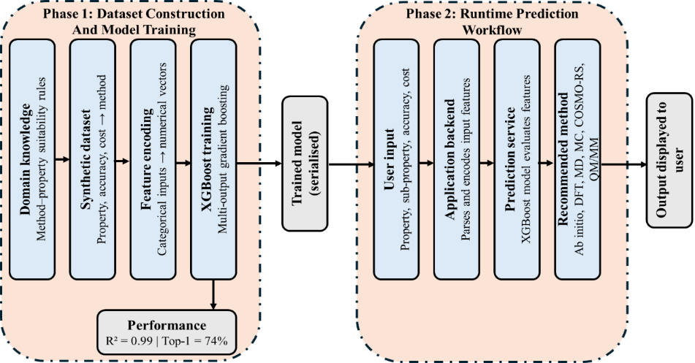
Figure 14: Workflow of the machine learning-assisted computational chemistry method recommendation framework.

6.2 Dataset Construction, Model Implementation, and Performance
The prediction engine employs an XGBoost multi-output regressor trained on structured tabular data encoding relationships between calculation requirements and established computational chemistry methods. Gradient boosting algorithms of this class are particularly well suited to tabular data, as they effectively capture nonlinear variable interactions while maintaining strong predictive performance on moderately sized datasets. Training data were constructed to represent combinations of property categories, sub-properties, accuracy requirements, and computational cost constraints, paired with the corresponding recommended method. Given the absence of comprehensively labelled empirical datasets characterizing these relationships in the literature, training examples were generated programmatically from established domain knowledge governing the practical suitability of various computational approaches for different property calculations. In this work, the synthetic dataset was designed to reflect the accuracy–cost trade-offs that typically govern method selection in computational chemistry practice. Model performance was evaluated across all six target computational chemistry methods using the coefficient of determination (R²) and root mean square error (RMSE) as primary metrics. As summarized in Table 11, the trained model achieved consistently high R² values across all methods, with individual scores ranging from 0.9824 (DFT) to 0.9968 (QM/MM). The overall R² of 0.9905 exceeds the predefined performance threshold of 0.96, confirming that the model captures the underlying methodological relationships with high fidelity. In terms of classification accuracy, the model achieved a Top-1 match rate of 74.45%, indicating that the highest-ranked recommendation corresponded to the expected method in approximately three of every four cases. This level of accuracy is considered acceptable for a proof-of-concept system operating, where inherent opacity in method selection particularly across computationally adjacent approaches is expected to constrain classification performance.
Table 11: Per-method predictive performance of the trained XGBoost multi-output regressor across the six target computational chemistry methods. The overall R² represents the aggregate score across all methods; no corresponding aggregate RMSE is reported.
Computational Method | R² | RMSE
Ab initio | 0.9948 | 0.0101
COSMO-RS | 0.9895 | 0.0391
DFT | 0.9824 | 0.0529
Monte Carlo (MC) | 0.9962 | 0.0180
Molecular Dynamics (MD) | 0.9835 | 0.0399
QM/MM | 0.9968 | 0.0096
Overall | 0.9905 | —
The framework presented here constitutes a proof-of-concept for the application of machine learning to methodological decision-making in computational chemistry. By combining structured domain knowledge with predictive modelling, it demonstrates the potential for such tools to assist researchers in identifying appropriate simulation techniques for a given engineering context. The dataset, trained model, and source code are provided as supplementary materials and made publicly available through an online repository (link provided below) to ensure full transparency and reproducibility.
https://github.com/ibrahimrasyid/cc-tool-upgrade-main

